# Practical-8

**Name of Experiment: Design the computational circuit for 4bit arithmetic circuit**

**Tools required: Logisim**

**Theory:**

**Designing a 4-bit arithmetic circuit involves creating a circuit that can perform various arithmetic operations on 4-bit binary numbers. Here’s a step-by-step guide to help you design such a circuit:**

**Components Needed**

1. **4-bit Full Adders: To perform addition and subtraction.**
2. **Multiplexers (MUX): To select different operations.**
3. **Logic Gates: AND, OR, NOT gates for logical operations.**
4. **Control Signals: To determine which operation to perform.**

**Steps to Design**

1. **Full Adder Design:**
   * **A full adder adds two bits and a carry-in to produce a sum and a carry-out.**
   * **For a 4-bit adder, you need four full adders connected in series.**
2. **Multiplexer Setup:**
   * **Use multiplexers to select between different operations (addition, subtraction, etc.).**
   * **Control signals (S0, S1, etc.) will determine the operation.**
3. **Arithmetic Operations:**
   * **Addition (A + B): Directly use the full adder.**
   * **Subtraction (A - B): Use the adder with B’s bits inverted (2’s complement method).**
   * **Increment (A + 1): Add 1 to the input using the adder.**
   * **Decrement (A - 1): Subtract 1 from the input using the adder.**
4. **Logic Operations:**
   * **AND (A & B): Use AND gates for each bit.**
   * **OR (A | B): Use OR gates for each bit.**
   * **NOT (~A): Use NOT gates for each bit.**

**4bit arithmetic circuit DAIGRAM:**

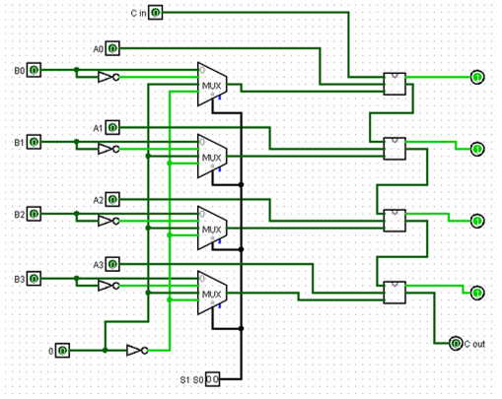

**TRUTH TABLE :**

